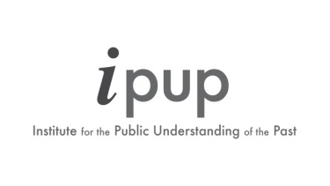
IPUP INTERNATIONAL WORKSHOP, 14TH-16TH SEPTEMBER 2016, UNIVERSITY OF YORK

Dr Meng Jiang, University of Renmin, Beijing
“The Developing Process and Problems of Public History in China”

Professor Julia Lajus, Higher School of Economics, St Petersburg
“Public and Applied History: New Trends in History Education in Russia”

Dr Indira Chowdhury, Srishti Institute, Bangalore
“The Predicaments of Legacy: the Institutional History of Science in India and its Challenges”

Professor Julie Parle, University of KwaZulu-Natal, Durban
“Supple States and Ubuntu in the Archives?: Reflections on History, Politics and Twenty Years of Democracy in South Africa”

Professor Marina de Mello e Souza, University of São Paulo
“Teaching African History: A Way to Build a Racially Equal Society in Brazil”

Professor Gerardo Boto Varela, University of Girona & Professor Marta Serrano Coll, University of Rovira I Virgili Tarrango
“Living Memories in Three Catalan Cathedral Cities: Medieval Transformations of Political and Ceremonial Spaces and their Continuing Relevance Today”

Dr Valika Smeulders, Netherlands
“Slavery and Public History in the Kingdom of the Netherlands: Developments in the Caribbean and Europe”

Professor Sloan Mahone, The Wellcome unit for the History of Medicine, University of Oxford
“Engaging with Healing and Healers: A Photo Repatriation Project in East Africa”

Dr Jessica Moody, University of Portsmouth
“Public Histories of Race, Slavery and Social Justice in the UK and US: The Jim Crow Museum and the International Slavery Museum”

Dr Dee Dyas & Louise Hampson, Centre for the Study of Christianity and Culture, University of York
“Understanding and Managing the Power of Place in English Cathedrals Past and Present”

Professor Sanjoy Bhattacharya & Dr Alex Medcalf, Centre for Global Health Histories, University of York
“Global Health Histories from Academic, Policy and Public Perspectives: A Study of Criticality and Negotiation”

Huw Halstead, University of York
“’Days that Resemble the Fall’: Commemoration of the 1453 Fall of Constantinople and the 1955 Istanbul Riots by the Expatriated Greeks of Istanbul”

Dr Edward Madigan, Royal Holloway, University of London
“The Long Shadow of the Great War: Anglo-Irish Relations and the Role of the Past in Violence and Reconciliation”

